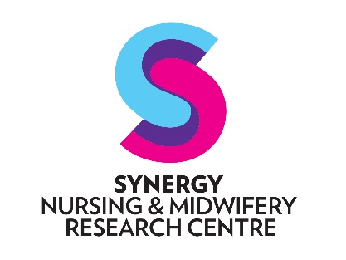

Research Internship Programme
2022 Application Form

Eligibility Criteria
Applicants must:
- Be employed as a Registered level 1 or 2, Midwife or Nurse (with a practicing registration) within a public health service in the ACT,
- Be willing and available to be seconded to Synergy 0.5FTE (weekdays) for 12 months, with management approval,
- Be supported by their line manager and operational Director of Nursing/Midwifery with final endorsement by the Executive Director of Nursing/Midwifery.
- Be willing to enrol in, and committed to completing, the Graduate Certificate in Research with the University of Canberra.

Full name:
Click here to enter text.
Employer (service and division):
Click here to enter text.
Name of line manager:
Click here to enter text.
Current FTE:
Click here to enter text.
Qualifications:
Click here to enter text.
Grade point average (for undergraduate qualifications in nursing or midwifery):
Click here to enter text.
Do you meet the eligibility criteria?
☐ Yes ☐ No
Please describe why you are interested in this secondment? (no more than 200 words)
Click here to enter text.
How do you see the knowledge and skills developed through this opportunity contributing to the mission/vision/values of your employer and benefit to service users? (no more than 300 words)
Click here to enter text.

Date: Click to enter a date.

Click here to enter applicant’s full name
____________________________________ ____________________________________
Print full name of Applicant Signature of Applicant

Click here to enter line manager’s full name
____________________________________ ____________________________________
Print full name of Line Manager Signature of Line Manager

