ACT Influenza Surveillance Report – No. 23, 2020
Summary: Influenza activity remains at a historic low in the ACT, with no cases notified in the last two weeks. This will be the last influenza surveillance report for 2020.
Influenza notifications
Reporting Period: 1 January to 11 October 2020, Weeks 1-41

Between 1 January and 11 October 2020, there were 194 notifications of influenza reported to ACT Health, with no cases notified with specimen collection in the last two weeks (Figure). In contrast, 3,936 and 409 cases were notified over the same period in 2019 and 2018, respectively.
Year to date, 87% (n=168) of notifications were influenza A and 8% (n=16) were influenza B. Ten cases (5%) were co-infected with influenza A and B, and this has been the predominant type detected (by serology) in the last 19 weeks. Of the 51 influenza A notifications with subtype information available, 42 (82%) were H1 and nine (18%) were H3.
Overall, notifications have been highest among adults aged 20-64 years (63%, n=122), with only 11% (n=22) of notifications in children aged 0-4 years, and 12% (n=24) in adults aged 65 years and over. However, the rate of infections for 2020 has been highest in the 0-4 year age group (78 infections per 100,000 age-specific population).

Figure. Number of influenza notifications, by week and year of specimen collection, 1 January 2015 to 11 October 2020, ACT.
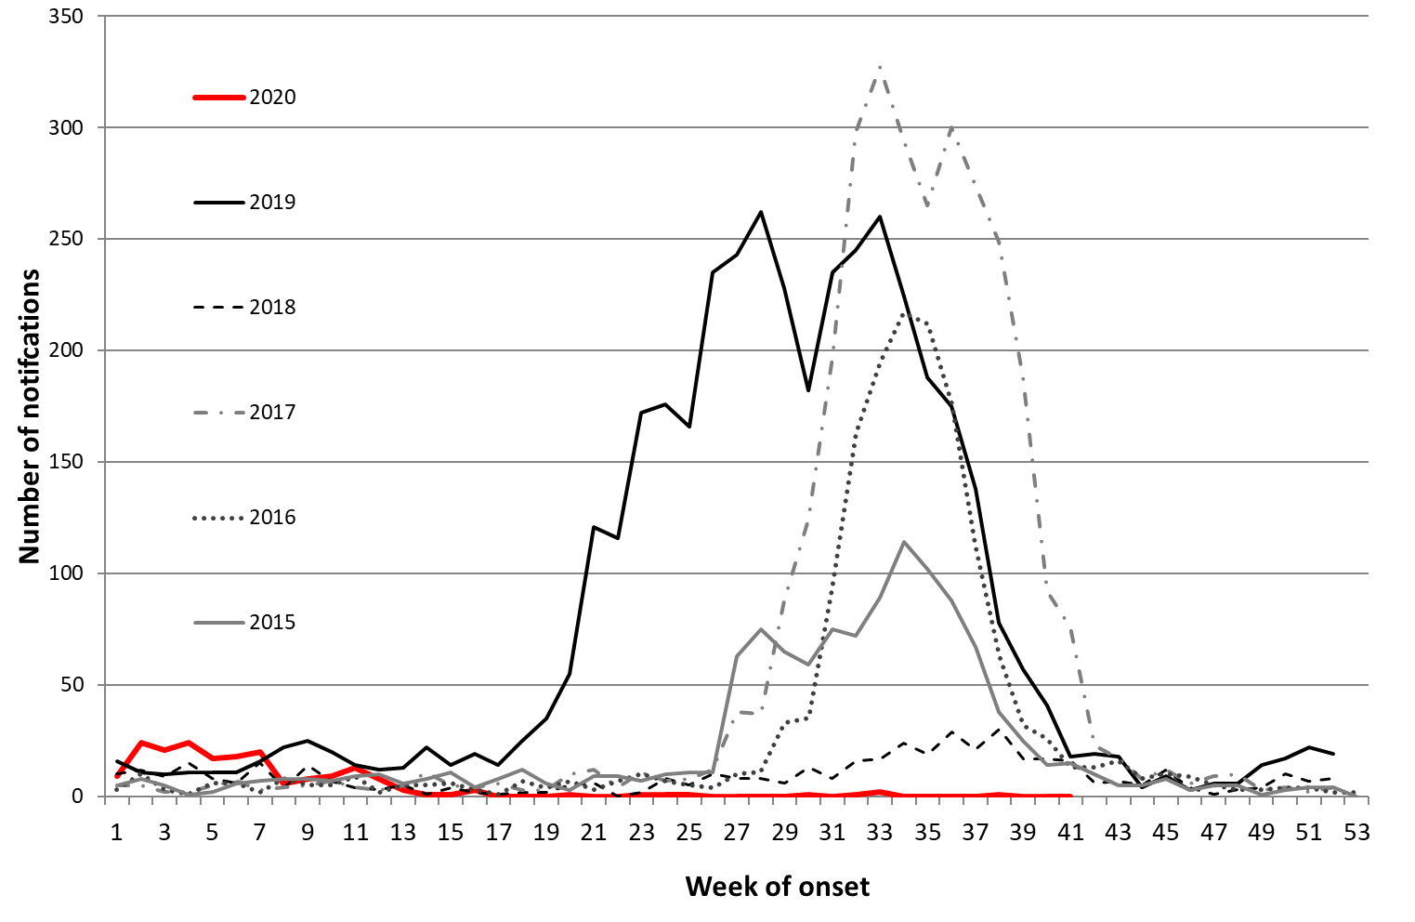
*Data provided for the current and most recent weeks may be incomplete. All data are preliminary and subject to change as updates are received.
Notification data include all cases diagnosed in residents of the ACT. Generally, notified cases represent only a small proportion of cases of influenza occurring in the community.
Notification data were exported on 12 October 2020 for the period 1 January 2015 to 11 October 2020, by specimen collection date.
Source: Notifiable Diseases Database, ACT, Communicable Disease Control Section, ACT Health.

