ACT Influenza Surveillance Report – No. 17, 2020
Summary: Influenza activity remains at a historic low, with no cases notified with onset in the last week.
Influenza notifications
Reporting Period: 1 January to 23 August 2020, Weeks 1-34

Between 1 January and 23 August 2020, there were 193 notifications of influenza reported to ACT Health, with no cases occurring in the last week (Figure). In contrast, 3,241 and 260 cases were notified over the same period in 2019 and 2018, respectively.
Year to date, 87% (n=167) of notifications were influenza A and 8% (n=16) were influenza B. Ten cases (5%) were co-infected with influenza A and B, and this has been the predominant type detected (by serology) in the last 18 weeks. Of the 51 influenza A notifications with subtype information available, 42 (82%) were H1 and nine (18%) were H3.
Overall, notifications have been highest among adults aged 20-64 years (63%, n=121), with only 11% (n=22) of notifications in children aged 0-4 years, and 12% (n=24) in adults aged 65 years and over. However, the rate of infections for 2020 has been highest in the 0-4 year age group (78 infections per 100,000 age-specific population).

Figure. Number of influenza notifications, by week and year of onset, 1 January 2015 to 23 August 2020, ACT.
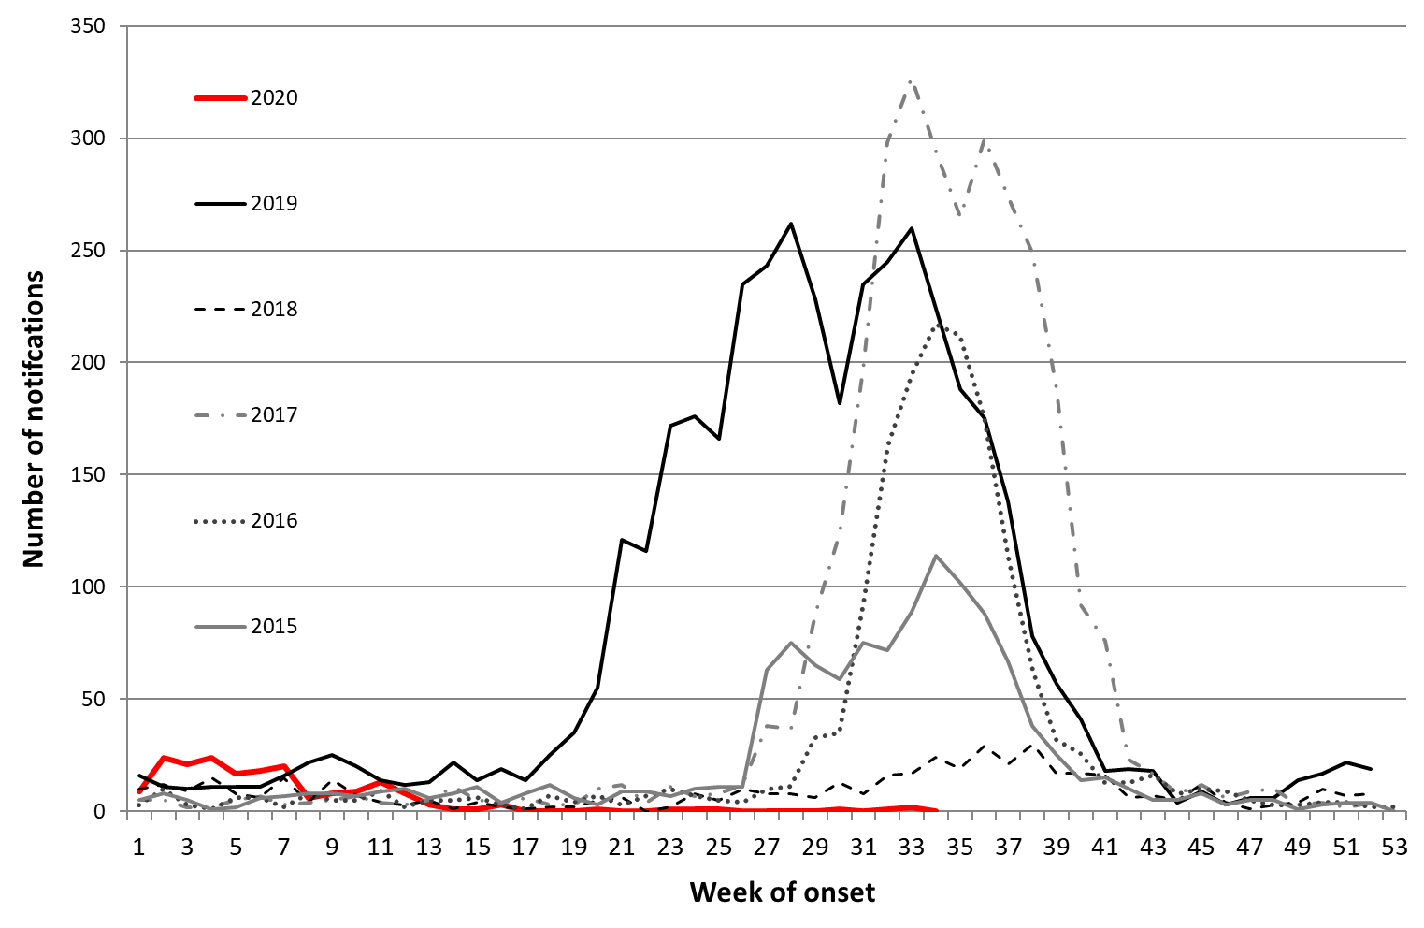
*Data provided for the current and most recent weeks may be incomplete. All data are preliminary and subject to change as updates are received.
Notification data include all cases diagnosed in residents of the ACT. Generally, notified cases represent only a small proportion of cases of influenza occurring in the community.
Notification data were exported on 24 August 2020 for the period 1 January 2015 to 23 August 2020, by onset date.
Source: Notifiable Diseases Database, ACT, Communicable Disease Control Section, ACT Health.

