EARLY CHILDHOOD
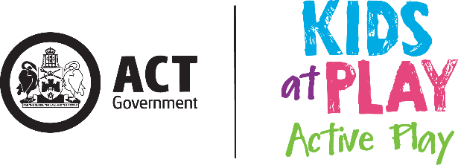

Active Play Audit Tool

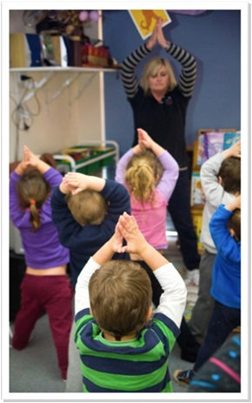
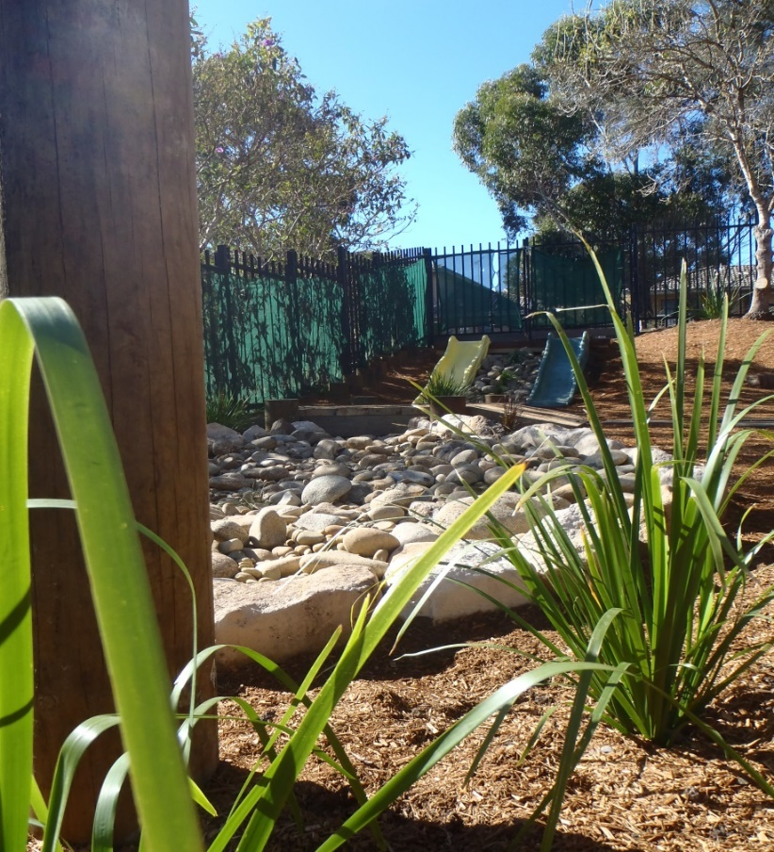
A tool developed to assist the ACT Early Childhood Education and Care (ECEC) sector to promote active play to children in their services

Completing this audit tool will assist your ECEC service to:

- Reflect the learning outcomes of the Early Years Learning Framework
- Meet requirements of the National Quality Standard
- Support development of your Quality Improvement Plan

Audit document approval details
Date completed: (This is the date on which the audit document was approved)
Approver: (List the name and position title of who approved the audit document)
This audit tool has been developed to assist the ACT Early Childhood Education and Care (ECEC) sector to promote physical activity to children in their services. Services can use this audit tool to evaluate their outdoor learning environment. It also provides educators with the opportunity to reflect on current practices and offers guidance to those seeking to improve both the quality of their outdoor learning environment, as well as increase physical activity levels in children.
Why do we need this Audit Tool?

To counteract sedentary lifestyles and obesity, outdoor play is particularly important for young children.
Evaluations undertaken as part of the Kids at Play Active Play have identified barriers in ECEC services in supporting children’s physical activity in the outdoor learning environment.
Related Research
- ‘Physical activity during the early childhood period is important as that is the time when children can learn and develop healthy behaviours which can then support them throughout their lives’ (Hinkey et al, 2008, pg1)

- Research suggests there is a strong relationship between physical activity levels and time spent outdoors (Hinkley et al, 2008, pg 3)

- ‘Having a high quality outdoor environment is not sufficient to encourage preschool physical activity. The educational approach is critical in facilitating children’s use of the outdoors.’ (Cosco, 2006, p14)
Australian 24-Hour Movement Guidelines for the Early Years
For pre-schoolers (aged 3 – 5 years), a healthy 24 hours includes:
- At least 180 minutes spent in a variety of physical activities, of which at least 60 minutes is energetic play, spread throughout the day; more is better.

- Not being restrained (eg stroller, car seat) for more than 1 hour at a time or sitting for extended periods. Sedentary screen time should be no more than 1 hour; less is better.

- 10 – 13 hours of good quality sleep.

Australian Government, Department of Health (2017)

Indoor and outdoor environments offer significantly different yet complementary experiences and should be given equal focus and attention. Well-designed indoor and outdoor environments can support the diverse interests, preferences and learning styles of all children in the service.
(ACECAQ, Guide to National Standard, 2013, p 93)
Please note:
Although this audit tool focuses on the outdoor learning environment, we recognise that the indoor learning environment must also be utilised to promote and support children’s physical activity and to meet current regulations, standards and recommendations.

Links to the National Quality Framework

This audit tool is in alignment with the Early Years Learning Framework (EYLF) and the National Quality Standard (NQS).
EYLF
The EYLF identifies the importance of physical activity through Learning Outcome 3: Children have a strong sense of wellbeing. This outcome acknowledges that ‘physical wellbeing contributes to children’s ability to concentrate, cooperate and learn… Physical activity and attention to fine and gross motor skills provide children with the foundations for their growing independence and satisfaction in being able to do things for themselves’ (EYLF p 33).
The layout of the outdoor learning environment plays a very important part in supporting children’s physical activity. The EYLF identifies ‘learning environments’ as one of the key practices required to promote children’s learning. The EYLF recognises the importance of ‘creating physical and social learning environments that have a positive impact on children’s learning’ (EYLF p 16)’. Additionally, outdoor learning spaces ‘invite open-ended interactions, spontaneity, risk-taking, exploration, discovery and connection with nature’ (EYLF p 18).
Further, the EYLF (p 18) tells us that ‘environments that support learning are vibrant and flexible spaces that are responsive to the interests and abilities of each child. They cater for different learning capacities and learning styles and invite children and families to contribute ideas, interests and questions’.
We need to carefully consider what materials we use within the outdoor learning environment as the EYLF (p 18) advises that ‘materials enhance learning when they reflect what is natural and familiar and introduce novelty to provoke interest and more complex and increasingly abstract thinking’ (EYLF p16).
Importantly, the outdoor learning environment provides extensive opportunities for effective interactions between the children and the environment with adults and with each other. The outdoors also provides educators with another opportunity to be positive, passionate, enthusiastic physically active role models to the children, colleagues, families and visitors.

National Quality Standard (NQS)

The importance of children engaging in physical activity at ECEC services is also recognised in the NQS and can be reflected within all 7 of the quality areas.

In particular, NQS Standard 2.1 states ‘Each child’s health and physical activity is supported and promoted’ and Element 2.1.3 ‘…physical activity are (sic) promoted and appropriate for each child’.

Implementing the Active Play Audit Tool into the ECEC Service.

Objectives of the Audit Tool
- To reflect upon the effectiveness of the learning environments in supporting children’s active play.
- To identify gaps in promoting children’s active play in the setting.
- To guide the development of an action plan to further promote active play in the learning environments and to strive for best quality - Quality Improvement Plan.

Outline of the Audit Tool

This ‘Active Play Audit Tool’ is divided into 6 sections:

1. Learning Spaces

2. Resources

3. Physical Development

4. Educators

5. Families

6. Additional Essential Elements

How to use the Audit Tool
- Each section begins with a question that asks services to reflect upon current practices. Record these reflections in the space provided on the audit tool.
- Use the listed considerations to assist with your reflection (e.g. for learning spaces, which of the spaces listed under ‘considerations’ does your service have?)
- Upon completion of this reflection process, record in the ‘Action Plan’ section your service’s strategies for increasing the active play opportunities in the different learning environments.
- Use the listed considerations to assist with developing your action plan (e.g. for learning spaces, are there spaces listed under ‘considerations’ that you do not have and would like to create in the future?)
- Your action plan can then be transferred to your service’s Quality Improvement Plan (QIP).

Audit Tool Implementation Flowchart
Schedule a team meeting to undertake the audit

Ensure each educator receives a copy of the entire audit tool at least 1 week prior to the team meeting.

Each educator must review and reflect upon each section of the audit tool in preparation for the team meeting.

At the team meeting work through the audit tool –including the introduction, followed by the reflective question, considerations and action plan for each section.

Transfer your action plan to your service’s Quality Improvement Plan

Address strategies in action plans, make changes.
Review again in 6-12 months

Section 1 - Learning Spaces
Reflective Question: What are the learning spaces in our ECEC service’s environment?

Considerations:
 | Animal Habitat |  | Dramatic Play |  | Cubby House |  | Quiet space
 | Shaded play area |  | Garden |  | Digging Pit |  | Sandpit
 | Stage / Platform |  | Grass Area |  | Open area |  | Water trough
 | Construction area |  | Hill / Mound |  | Bike Paths |  | Softfall
Action Plan: (What spaces do we have that we are not using? What spaces do we need to create? What changes can we make so that our learning spaces better facilitate active play? How can indoor spaces be modified to create additional play spaces in poor (too hot, too cold, too wet) weather?)

Outdoor Spaces ‘foster an appreciation of the natural environment, develop environmental awareness and provide a platform for ongoing environmental education.’ (EYLF, p.16)

Section 2 - Resources
Reflective Question: Within the identified learning spaces from Section 1, what resources are available to encourage children’s active play?

Considerations:
 | A-frame trestles |  | Climbing trees |  | Scooters |  | Sticks |  | Steps
 | Animal figures |  | Dry creek bed |  | Shade |  | Pipes |  | Streamers
 | Stepping stones |  | Watering cans |  | Tree stumps |  | Bikes |  | Balls
 | Work bench |  | Flying fox |  | Pots |  | Spades |  | Shells
 | Wheel barrows |  | Bean bags |  | Rakes |  | Buckets |  | Swing
 | Edible plants |  | Hoops |  | Ramps |  | Chalk |  | Targets
 | Scooter Boards |  | Ladders |  | Ribbons |  | Wood |  | Tree logs
 | Brooms |  | Music |  | Ropes |  | Pebbles |  | Tyres
 | Boats |  | Paint |  | Scarves |  | Photos |  | Trestles
 | Books |  | Pinecones |  | Shovels |  | Camera |  | Trucks
 | Variety of walking surfaces |  | Dramatic play  props |  | Kitchen equipment |  | Hammer and nails |  | Magnifying glass
Action Plan: (What resources do we have that we are not using? What resources do we need to get? How can we use recycled materials to make active play equipment? What changes can we make so that our resources better facilitate active play?)

Physical environments at services should include a range of activity opportunities to support children’s physical activity, including a variety of portable and fixed play equipment and adequate shading. (Hinkley et al, p4)

Section 3 - Physical Development
Reflective Question: During children’s active play, what areas of physical development or Fundamental Movement Skills are being promoted?

Considerations : (Areas of physical development)
 | Tummy time |  |  |  | Sitting balance |  |  |  | Rolling |  | Crawling
 | Pivoting on Tummy |  |  |  | Creeping on tummy |  |  |  | Cruising |  | Pulling to stand
 | Muscle strength |  |  |  | Coordination eye-hand |  |  |  | Flexibility |  | Walking
 | Body awareness |  |  |  | Coordination eye-foot |  |  |  | Dexterity |  | Cross-patterning
 | Agility |  |  |  | Cardiovascular fitness |  |  |  | Skipping |  | Bone strength
 | Balance |  |  |  | Spatial awareness |  |  |  | Posture
Considerations : (Fundamental Movement Skills)
 | Hopping |  | Stationary dribbling |  |  |  | Catching |  |  |  | Galloping
 | Running |  | Overarm throwing |  |  |  | Underarm rolling |  |  |  | Side sliding
 | Jumping |  | Striking a stationary ball |  |  |  | Kicking |  |  |  | Leaping
Action Plan: (What areas of physical development or fundamental movement skills do the children in our care need to be working on? Are there specific skills that need to be taught? Are there games or activities we can introduce to the children to promote the development of specific physical skills?)

‘Children being encouraged and supported to use increasingly complex sensory motor skills and movement patterns that:
* combine gross and fine motor movement and balance
* increase their spatial awareness
* use their problem-solving skills’ (NQS – Element 2.2.2 – Guidance)

Section 4- Educators
Reflective Question: As an educator, how do you support children’s active play and physical development through the identified learning spaces and resources?

Considerations : (Interactions)
 | Individual – one to one |  | Shared – small group |  |  |  | Shared – large group
Considerations : (Role modelling)
 | Curiosity |  | Enthusiasm |  |  |  |  | Participation
 | Demonstration |  | Imagination |  |  |  |  | Passion
Considerations : (Other)
 | Accessing community resources (built, space, human) |  | Awareness of children’s individual needs |  |  | Scaffold children’s physical skills
 | Embedding active play into the everyday curriculum |  | Observational recordings and evaluations |  |  | Provide positive constructive feedback
 | Being aware of spontaneous opportunities |  | Include active play in professional conversations |  |  | Conversations with families
 | Provide opportunities for risk taking and challenge |  | Planning intentional experiences (GMS and FMS) |  |  | Provide quality & sufficient resources
 | Sharing with children the benefits of being active |  | Building on children’s interests |  |  | Being culturally inclusive
 | Including children in planning and set-up of active play |  | Excursions/ incursions
Action Plan: (What changes do we need to make to the way we interact with children and model active play? Are there opportunities or experiences that we need to include in our program to better facilitate active play?)

Educators ‘consistently implementing movement and physical activities as part of the program for all children’. (NQS – Element 2.2.2 – Guidance)

Section 5 - Family
Reflective Question: How do we share with families the importance of active play?

Considerations :
 | Being an active role model |  | Conversations with families |  | Daily diary / journal
 | Embed active play into the program |  | Family active play journal to share with service |  | Noticeboards / Photos / Newsletters
 | Invite families to participate in physical experiences |  | Invite families to share their active play interests |  | Special active play events
Action Plan: (How can we be better at sharing the importance of active play with families and supporting them to do regular active play with their children?)

‘Evidence that information about the importance of physical activity to children’s health and development is communicated to families.’ (NQS – Element 2.2.2 – Guidance)

Partnerships – ‘Learning outcomes are most likely to be achieved when early childhood educators work in partnership with families.’ (EYLF Principle, pg12)

Section 6- Additional Essential Elements
Reflective Question: What additional essential elements need to be considered in supporting active play in the learning environment?

Considerations :
 | Adequate shade |  | Early Years Learning Framework |  | Sustainability
 | Adequate space |  | E&C Services National law |  | Supervision
 | Ample time |  | National Quality Standard |  | Kidsafe guidelines
 | Appropriate clothing |  | Physical activity policy |  | Sunsmart guidelines
 | Routines |  | Physical activity recommendations |  | Appropriate footwear
 | Cost effectiveness |  | Workplace Health & Safety |  | Active Play Everyday
Action Plan: (What else can we do to better facilitate active play at our centre? Do we have a physical activity policy? If not, complete the Physical Activity and Small Screen Recreation Policy.)

‘Cancer Council ACT recommends SunSmart behaviour when daily UV levels reach 3 and above. Sun protection is generally not recommended in Canberra during June and July or when UV levels are low (under 3).’

References

Australian Children’s Education & Care Quality Authority (ACECQA) (2018) National Quality Framework Information sheet: Revised National Quality Standard and Other Changes.
Australian Government, Department of Education, Employment and Workplace Relations (DEEWR) (2009a) Belonging, Being & Becoming: The Early Years Learning Framework for Australia. Canberra, ACT: DEEWR

Australian Government, Department of Health and Ageing (2017) Australian 24-Hour Movement Guidelines for the Early Years (birth to 5 years). Canberra

Cancer Council ACT (2016) Cancer Council’s National SunSmart Early Childhood Program www.actcancer.org/prevention/sunsmart/act-schools-and-early-childhood-services/national-early-childhood-program/

Cosco, N. (2006) Motivation to Move: Physical Activity Affordances in preschool Play Areas. Heriot Watt University. Edinburgh

Gosford Council and Wyong Council (2007) Climbing the little green steps: How to promote sustainability within early childhood services in your local area. Gosford City Council.
(page 29)

Hestenes, L. DeBord, K. Moore, R. Cosco, N. & McGuinnis, J. (2005) Preschool Outdoor Environment Measurement Scale (POEMS). Winston Salem: Kaplan Company

Hinkley, T & Salmon, J. (2011) Correlates of Physical Activity in Early Childhood. Encyclopedia on Early Childhood Development.

The Early Years Learning Framework Professional Learning Program e-Newsletter No.11 2011: Spaces for children

The Early Years Learning Framework Professional Learning Program e-Newsletter No.25 2011: Learning Spaces 1: Outdoors

The National Quality Standard Professional Learning Program e-Newsletter No.29 2012: Health, Safety and Wellbeing

The National Quality Standard Professional Learning Program e-Newsletter No.30 2012: An environment for learning

