ACT Influenza Surveillance Report – No. 12, 2020
Summary: Influenza activity continues at a historic low, with no cases notified in the ACT with onset in the last four weeks. Only four cases have been notified in the last 13 weeks.
Influenza notifications
Reporting Period: 1 January to 19 July 2020, Weeks 1-29

Between 1 January and 19 July 2020, there were 189 notifications of influenza reported to ACT Health, with no cases occurring in the last four weeks (Figure). Seventy percent (133) of all notifications were made in the first seven weeks of the year.
Year to date, 88% (n=166) of notifications were influenza A and 8% (n=16) were influenza B. Seven cases (4%) were co-infected with influenza A and B, and this has been the predominant type detected (by serology) in the last 14 weeks. Of the 51 influenza A notifications with subtype information available, 42 (82%) were H1 and nine (18%) were H3.
Overall, notifications have been highest among adults aged 20-64 years (62%, n=118), with only 10% (n=22) of notifications in children aged 0-4 years, and 12% (n=23) in adults aged 65 years and over. However, the rate of infections for 2020 has been highest in the 0-4 year age group (78 infections per 100,000 age-specific population).

Figure. Number of influenza notifications, by week and year of onset, 1 January 2015 to 19 July 2020, ACT.
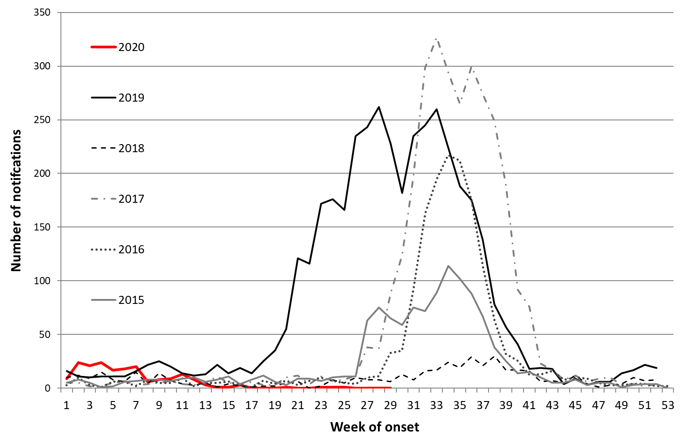
*Data provided for the current and most recent weeks may be incomplete. All data are preliminary and subject to change as updates are received.
Notification data include all cases diagnosed in residents of the ACT. Generally, notified cases represent only a small proportion of cases of influenza occurring in the community.
Notification data were exported on 20 July 2020 for the period 1 January 2015 to 19 July 2020, by onset date.
Source: Notifiable Diseases Database, ACT, Communicable Disease Control Section, ACT Health.

