National Cervical Screening
How to Fill Out the Pathology Request Form
In order for ACT Pathology to perform the correct test and provide the appropriate recommendation on your patient’s sample, as well as correctly bill to Medicare, it is important that the pathology request form is completed correctly.

The following are guidelines for requesting cervical tests depending on the clinical scenario:
Previous Endocervical Adenocarcinoma In-Situ (AIS)

Patients with previously treated AIS require annual co-testing.
The pathology request form for these women should state “Cervical co-test – Previous AIS”.

Other Useful Information
Other useful clinical information includes:
∗ Immunodeficient
∗ Previous hysterectomy (indication included)
∗ Abnormal uterine bleeding
∗ DES exposure.
‘Opting Off’ the Register
It is now the responsibility of the patients or their medical practitioner to notify the NCSR if patients wish to “opt off” the National Cancer Screening Register. This function can no longer be performed by the Laboratories.
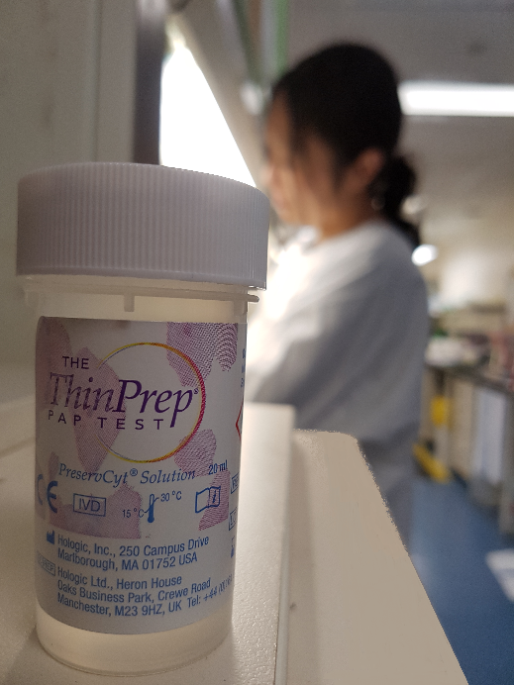

Asymptomatic Patients – Women Over 25 Years of Age

Most of your patients will have no significant previous history or symptoms. These women, who are over 25, will receive a postal invitation from the National Cancer Screening Register (NCSR) for a routine cervical screening test every five years.
The Pathology Request Form for These Women Should State “Routine – Cervical Screening Test”.
The laboratory will do HPV testing and/or liquid based cytology as appropriate.
Symptomatic Patients
Women of any age who are symptomatic (e.g. post-menopausal bleeding) may require HPV and liquid-based cytology performed on their specimen i.e. Co-testing.
The pathology request form for these women should state “Cervical co-test - Symptomatic”.
A description of the relevant symptoms should also be added.

Follow up of Previous Abnormal Cervical Screening
If a women’s previous cervical screening test has produced a High Risk HPV DNA ‘DETECTED’ result and the recommendation was for follow up testing, this should be clearly stated on the pathology request form.
The pathology request form for these women should state “cervical test, follow up of previous abnormal result”.

Test of Cure
Women who have had a previously treated high grade squamous intraepithelial lesion (HSIL of CIN2/3) will require two consecutive tests where High Risk HPV DNA is ‘NOT DETECTED’ and liquid-based cytology tests are negative 12 months apart, before they are considered to be cured. The patient can then return to a routine screening interval of 5 years.
The pathology request form for these women should state “Cervical co-test – Test of Cure”.

