Canberra Hospital and Health Services
Clinical Procedure
Acute Screening of Swallow in Stroke/Transient Ischaemic Attacks (ASSIST) for Adults

Contents

Contents 1
Purpose 2
Alerts 2
Scope 2
Section 1 – Procedure 3
Implementation 4
Related Policies, Procedures, Guidelines and Legislation 4
References 5
Definition of Terms 5
Search Terms 6
Attachments 6
Attachment 1 – The Canberra Hospital Acute Screening of Swallow in Stroke / TIA Form 7

Purpose

To ensure all Stroke/Transient Ischaemic Attack (TIA) patients at risk of dysphagia are identified early through swallowing screening and referred to speech pathology for timely assessment and management.

27-64% of patients experience dysphagia following stroke. Implementation of formal dysphagia screening by trained health professionals can help reduce the incidence of complications such as aspiration and pneumonia. (Clinical Guidelines for Stroke Management 2017).

Complications of undetected and unmanaged dysphagia include dehydration, malnutrition, suboptimal medication administration, and aspiration pneumonia subsequently increasing length of hospital stay.

Back to Table of Contents

Alerts

- The Acute Screening of Swallow in Stroke/TIA (ASSIST) is an evidence based tool for adult stroke/TIA patient populations, it must not be used to screen swallowing in other patient groups. If dysphagia is suspected in a non-stroke patient, medical referral to Speech Pathology is recommended.
- The ASSIST is NOT a screen of a patient’s communication abilities. If any communication impairment is noted during the assessment that has not resulted in the patient automatically failing the ASSIST, the patient should be referred for Speech Pathology management of communication following completion of the ASSIST.

Back to Table of Contents

Scope

This procedure applies to the following:
- Medical Officers
- Nurses and Midwives who are working within their scope of practice (Refer to Scope of Practice for Nurses and Midwives Policy)
- Speech pathologists

Acute stroke/TIA patients will be screened for dysphagia by a trained nurse with the Acute Screening of Swallow in Stroke/TIA (ASSIST). The ASSIST is an evidence based and reliable screening tool, which will identify if the patient is:
- Safe to commence oral intake
OR
- At risk of aspiration and requires assessment and management from a speech pathologist
AND
- In need of alternative (non-oral) routes of nutrition, hydration and medication administration until speech pathology assessment occurs.

Training
Speech Pathology is responsible for provision of ASSIST training to nursing staff working in the Stroke Unit, Emergency Department and the after-hours clinical nurse consultants. On completion of training, nursing staff are required to pass a written assessment prior to administering the ASSIST.

Emergency Department and Stroke Unit Clinical Development Nurses will advise Speech Pathology when training sessions are required and will maintain documentation of staff trained in the administration of the ASSIST.

Only staff trained in the ASSIST, including passing the written assessment are able to administer the ASSIST.

Back to Table of Contents

Section 1 – Procedure

The ASSIST is an evidence based tool for adult stroke/TIA patient populations, it must not be used to screen swallowing in other patient groups. If dysphagia is suspected in a non-stroke patient, medical referral to Speech Pathology is recommended.
An ASSIST trained nurse must complete the ASSIST within 4 hours of admission to hospital and before the patient is given any oral food, fluid, or medication. If an ASSIST trained nurse is not available the patient must be kept nil by mouth (NBM), the treating team be notified, and a referral made to speech pathology.

The form for completing the ASSIST is located on the Clinical Records Forms Register on the intranet and is attached.

- Confirm correct identity of the patient as per the `Patient Identification and Procedure Matching’ Clinical Procedure and that he/she has a newly diagnosed acute stroke/TIA.
- If the patient has not had an acute stroke/TIA, discuss with medical team signs of dysphagia and refer to Speech Pathology if indicated.
- If the patient has already been assessed by speech pathology since the diagnosis of stroke/TIA, refer to recommendations provided by the speech pathologist regarding commencement of safe food and fluid textures. Completion of the ASSIST is not required if the patient has been assessed by Speech Pathology.
- Commence the ASSIST at question one. Follow the prompting and cease immediately if at any point the patient fails the ASSIST tasks. If a patient fails question one of the ASSIST, trained staff may restart the tool again at a more suitable time.
- For patients who fail the ASSIST, place NBM and refer to speech pathology.
NB Questions 2-5 of the ASSIST may only be administered again after 24 hours
- Where a delay in speech pathology assessment occurs (i.e. after hours and weekends), nursing staff are to notify the medical team when the patient has failed the ASSIST to consider alternate forms of nutrition, hydration and medication administration.
- For patients who pass the ASSIST, commence them on their premorbid diet and fluids – this may require discussion with the patient’s family/carer or their place of residence (e.g aged care facility) to determine premorbid diet/fluids.
- Observe the patient with their first meal following the ASSIST. If the patient has any difficulty chewing and swallowing this diet, place the patient NBM and refer to Speech Pathology.
- Document completion of screening process in progress notes and place the completed, signed and dated ASSIST form in the patient’s medical record.

Alert:
The ASSIST is NOT a screen of a patient’s communication abilities. If any communication impairment is noted during the assessment that has not resulted in the patient automatically failing the ASSIST, the patient should be referred for Speech Pathology management of communication following completion of the ASSIST.

Back to Table of Contents

Implementation

This procedure will be implemented and communicated to the affected staff by being incorporated into existing training programs, orientation plans and by specific communication strategies eg placed in tea rooms etc and alerting staff to the new procedure through email.

Back to Table of Contents

Related Policies, Procedures, Guidelines and Legislation

Policies
- Health Directorate Nursing and Midwifery Continuing Competence Policy
- Consent and Treatment
- Patient Identification and Procedure Matching Policy

Procedures
- Healthcare Associated Infections Clinical Procedure
- Patient Identification and Procedure Matching Procedure

Legislation
- Health Records (Privacy and Access) Act 1997
- Human Rights Act 2004
- Work Health and Safety Act 2011

Back to Table of Contents

References

- National Institute for Health and Care Excellence, 2017. NICE Pathways, Stroke. Assessing swallowing function and oral nutrition. https://pathways.nice.org.uk/pathways/stroke#path=view%3A/pathways/stroke/acute-stroke.xml&content=view-node%3Anodes-assessing-swallowing-function-and-oral-nutrition
- National Stroke Foundation, Clinical Guidelines for Stroke Management 2017. Melbourne, Australia.
- Canadian Stroke Best Practices, 2015. Acute Inpatient Stroke Care. http://www.strokebestpractices.ca/acute-stroke-management/

Back to Table of Contents

Definition of Terms

Dysphagia – difficulty/disruption in the process of swallowing saliva/ food / fluids.

Aspiration – the inhalation of a foreign substance, i.e. food / fluid / saliva into the airway / lungs.

Nil By Mouth – no food, drink by mouth, including ice chips and medications.

Dehydration – the body does not have as much water and fluids as it should. Dehydration can be caused by losing too much fluid, not drinking enough water.

Malnutrition – the condition that occurs when a person's body is not getting enough nutrients.

Screening of Swallowing – a process to identify any clinical indicators of dysphagia / aspiration risk. Screening identifies those patients that require speech pathology assessment.

Premorbid diet / fluids – these are the diet and fluid requirements that the patient had prior to admission to hospital (includes personal, cultural and other food/diet preferences, e.g. diabetic)

Back to Table of Contents

Search Terms

Stroke, Transient Ischaemic Attack, TIA, Dysphagia, Swallow, ASSIST

Back to Table of Contents

Attachments

Attachment 1 – The Canberra Hospital Acute Screening of Swallow in Stroke / TIA Form.

Disclaimer: This document has been developed by ACT Health, Canberra Hospital and Health Services specifically for its own use. Use of this document and any reliance on the information contained therein by any third party is at his or her own risk and Health Directorate assumes no responsibility whatsoever.

Policy Team ONLY to complete the following:
Date Amended | Section Amended | Divisional Approval | Final Approval
14/03/2018 | Complete Review | Girish Talaulikar, ED Medicine | CHHS Policy Committee

This document supersedes the following:
Document Number | Document Name
CHHS12/305 | Acute Screening of Swallow in Stroke or Transischaemic Attack (ASSIST)

Attachment 1 – The Canberra Hospital Acute Screening of Swallow in Stroke / TIA Form
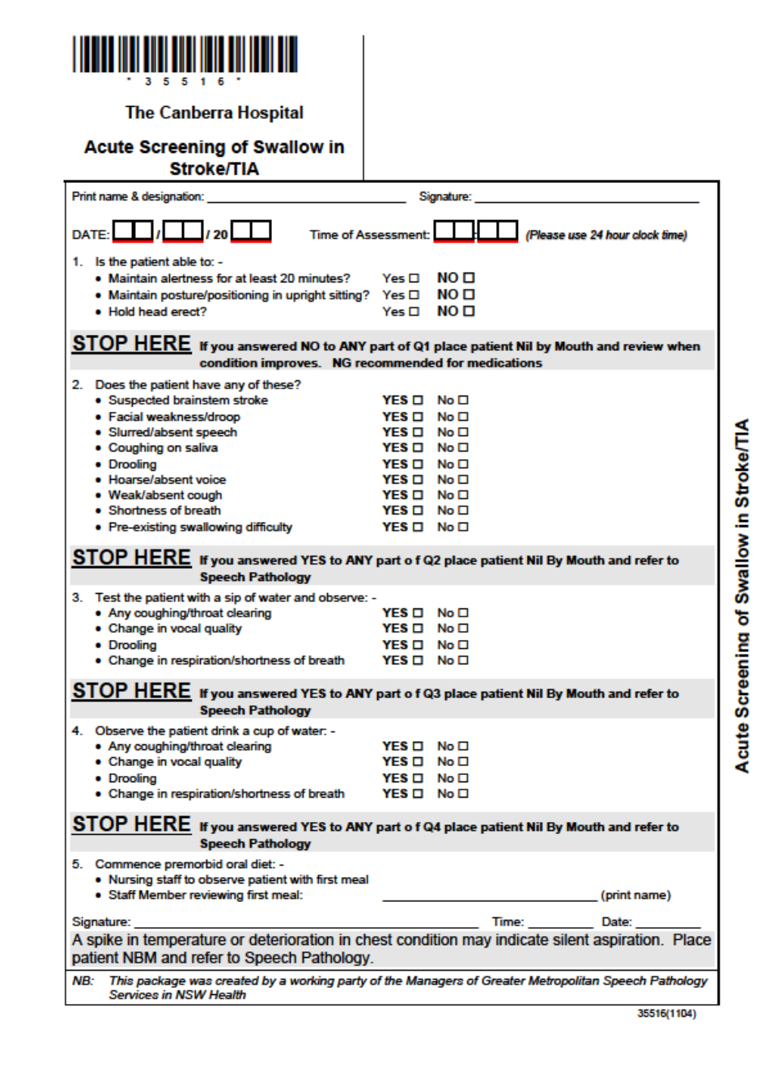
Sample

