Canberra Hospital and Health Services
Clinical Procedure
Pressure Injury Prevention and Management: Adults, Children and Neonates

Contents

Contents 1
Purpose 2
Scope 2
Section 1 – Governance and Systems in the Prevention and Management of Pressure Injuries 2
Section 2 – Prevention of Pressure Injuries 3
Section 3 – Management of Pressure Injuries 5
Section 4 – Communicating with Patients and Carers 7
Implementation 8
Related Policies, Procedures, Guidelines and Legislation 8
References 8
Definition of Terms 9
Search Terms 10
Attachments 10
Attachment 1: Clinical guideline 11
Attachment 2: Waterlow Risk Assessment Tool 12
Attachment 3: Braden Q Scale for Paediatric Patients 13
Attachment 5: Modified Waterlow Risk Assessment Tool (used in Maternity and some OPD settings) 16
Attachment 6: Braden Risk Assessment Tool (used by Occupational Therapy) 17
Attachment 7: Classification photos 18

Purpose

The purpose of this procedure is to provide a comprehensive, coordinated and systematic approach, for pressure injury prevention and management across Canberra Hospital and Health Services that includes governance, structures and systems, and the use of best available evidence. This clinical procedure is consistent with the National Safety and Quality Health Service Standards and national and international recognised guidelines.

It provides clinicians and senior managers with direction and resources to implement evidence based systems to recognise the risk factors and prevent pressure injuries, and to manage them when they occur.

Scope

This procedure applies to all ACT Health staff responsible for the safe and effective prevention and management of pressure injuries for all patients at the Canberra Hospital and Health Services (CHHS).

This document applies to the following Canberra Hospital Health Services (CHHS) staff working within their scope of practice:
- Medical Officers
- Nurses and Midwives
- Allied Health professionals
- Students under direct supervision

Section 1 – Governance and Systems in the Prevention and Management of Pressure Injuries

ACT Health has an organisational framework for the prevention and management of pressure injuries supported by evidenced based tools and guidelines. The overarching monitoring group is the Pressure Injuries Standards Committee. The committee has an Executive Sponsor, a Clinical Lead and Director of Nursing sponsor, representatives from each Division, a lead Quality Officer and consumer representative. This committee reports to the National Standards Steering Committee.

There are a number of mechanisms for reporting pressure injuries within ACT Health. Clinical incidents are reported via RiskMan which is accessible to all staff via the intranet. A wound extension module within RiskMan (WEM) captures elements of best practice implemented for the individual patient and improves reporting of the pressure injury, including whether the injury was present on admission or facility acquired.

Governance of the Pressure Injury Standard is well supported by a number of regular audits, Pressure Injury Prevalence Surveys (PIP) and monitoring of clinical incidents particularly facility acquired pressure injuries.

Back to Table of Contents

Section 2 – Prevention of Pressure Injuries

Patients are assessed by nurses/midwives on presentation to Canberra Hospital, and at their first visit in the Community Care Program (CCP).

Staff should follow the CHHS Pressure Injury Prevention and Management Clinical Interventions Guideline – (Attachment 1)

Risk assessment
CHHS endorses the following tools for pressure injury risk assessment:
- Waterlow Risk Assessment Tool (WRAT) - for adults (see Attachment 2)
- Braden Q Risk Assessment Scale - for paediatrics (age <15years) (Attachment 3)
- Neonatal skin assessment in NICU and SCN (Attachment 4)
- Modified version Waterlow tool (2005) in Maternity (Attachment 5)
- Braden Risk Assessment Scale within the community (Allied Health) (Attachment 6)

Staff must complete a pressure injury risk assessment, using the designated tool, and a comprehensive skin integrity check, to identify those patients at risk of developing a pressure injury. Clinical judgement is essential when using a risk assessment tool for pressure injury.

A pressure injury risk assessment should be conducted:
- on admission to hospital, or at the initial home or clinic visit for patients seen in the CCP, and documented in the patient’s clinical record. Patients and carers must be informed of the potential risks of developing a pressure injury and the prevention strategies used. If a pressure injury is present then an explanation of stage or category of injury is given and a management plan is developed in partnership with patient and carers
- on admission to the Emergency Department, or as soon as possible for patients undergoing resuscitation or other priority interventions.

A risk assessment includes a full body skin integrity assessment, examining bony prominences, and particularly under medical devices, to look for alterations to intact skin. When assessing darkly pigmented skin, prioritise skin temperature, oedema and change in tissue consistency. Staff should undertake microclimate management including incontinence management e.g. pH balanced skin cleansers and moisturizers, and incontinence products measured to fit.

Pain should be regularly assessed and effective pain management should be instigated as required.

A skin integrity assessment is conducted using a structured approach to risk assessment, informed by knowledge of relevant risk factors and clinical judgement and should be performed:
- daily in Canberra Hospital and more frequently if there is a significant change in the patient’s condition
- after a prolonged procedure where the patient has been immobile or had surgery
- at home/clinic appointment for CCP patients, Outpatient clinics, Ambulatory Care Clinics and Walk in Centres
- prior to discharge or transfer to other wards or facilities.

Risk factors
Most risk assessment tools incorporate many of the risk factors.

Factors for consideration include:
- Perfusion and oxygenation
- Poor nutritional status
- Increased skin moisture
- Increased Body temperature
- Advanced age
- Sensory perception
- Haematological measures and
- General health status.

Risk factors can be divided into intrinsic and extrinsic
Extrinsic factors
- pressure
- impaired mobility
- impaired activity
- impaired sensory perception
- tissue tolerance
- friction
- shear
- skin moisture/microclimate

Intrinsic factors
- nutrition
- demographics
- oxygen delivery
- chronic illness
- skin temperature

Resources for Pressure Injury Prevention
The following resources are available for staff to use in the prevention of pressure injuries:
- alternating air mattresses for patients with a pressure injury
- chair cushions for patients with a pressure injury or at risk
- heel troughs to off load heels off the bed surface for patients with a pressure injury or at risk
- slide sheets, to be used at all times for moving patients within a bed and onto a chair
- lifters, hover mats and Skin IQ (only available on Tissue Viability Unit (TVU)) recommendation) are additional resources available from Canberra Equipment Service (CES)
- consider applying silicone foam dressing to bony prominences, e.g. sacrum and heels. Assess skin integrity under dressing daily.

All equipment mentioned can be ordered through CES at Canberra Hospital and ACT Equipment Scheme in the community. All patients who are wheelchair dependent require review of wheelchair and cushion by the Occupational Therapist (OT).

Special populations
Specific patient populations are at greater risk of developing pressure injuries and particular care is taken to implement preventative strategies to meet the special needs of these patient groups:
- Bariatric
- Critically ill
- Older adults
- Labouring women with an epidural
- Patients in the operating room
- Patients with a spinal cord injury
- Patients in palliative care
- Paediatric patients
- Neonates
- Out patients/walk in centres.

Back to Table of Contents

Section 3 – Management of Pressure Injuries

Wound Management Plan
Staff should follow the CHHS Pressure Injury Prevention and Management Clinical Interventions Guideline – (Attachment 1) in the management of pressure injuries. A wound management plan must be developed when a pressure injury is identified.

Staff must include the following in the management plan:
- referrals to health professionals, such as Dietician and OT for those patients identified at risk or with a stage 2 pressure injury or above
- prescribing of nutritional supplements if required

Patients must be assessed and reviewed at each dressing change, and staff should document the stage of the pressure injury, its location and if facility/community acquired.

A care plan to prevent/manage pressure injuries should be completed at each shift or home/clinic visit and placed in the patient’s clinical record. The pressure injury risk and a plan must be communicated at clinical handover.

Reporting a Pressure Injury
If a pressure injury is noted on admission, or develops during the course of admission, a RiskMan report must be completed and referred to the Tissue Viability Unit and/or Nurse Practitioner (NP)/Clinical Nurse Consultant (CNC) CCP via Riskman or a phone call. Note that all reported pressure injures are assessed by the Tissue Viability Unit at Canberra Hospital and NP/CNC in the CCP.

A Service Review will occur for any stage 3 or 4 pressure injuries, including suspected deep tissue injury or unstageable, that is facility/CCP acquired. An in-depth analysis will be conducted by the relevant CNC/NP in the clinical area where the pressure injury was reported. The incident review will identify if the pressure injury was avoidable or unavoidable and is reported at the CHHS Pressure Injuries Standards Group. Divisions are required to communicate outcomes and recommendations to staff and take action as appropriate.

Medical Device Related Pressure Injury
Pressure injuries may develop as a result of prolonged and unrelieved pressure from a medical device. Often the devices are required for treatment and management of a patient’s medical needs. Staff should note the following when caring for a patient who has a medical device related pressure injury:
- Tubes should be repositioned in the mouth every 4hrs/PRN. Mucosal injuries are found on mucous membranes such as tongue, nasal passages or oral mucosa and are caused by oral tubing/equipment
- Neonates are checked with routine care for pressure injuries from any medical devices and tapes, more frequently if the score indicates this necessity (attachment 4).The Neonatal skin Risk Assessment score and action taken is also documented
- Use an endotracheal attachment device for a patient who will be intubated for more than 24 hours. Cotton tape should be replaced every 24hrs/PRN
- Miami J/hard collars used in spinal precautions should be removed every 4 hours/PRN to inspect the underlying skin and tissue and change padding when soiled
- A clear documented order from the Medical Officer should determine when splints or back slabs can be removed. At this time a skin integrity assessment should be completed
- If splints cannot be removed for medical reasons, document this in the patient’s clinical record
- Ensure splints and back slabs are well padded. Ask patients to report any areas that are uncomfortable or painful, particularly over bony prominences
- Note that patients who have peripheral neuropathy and spinal injury do not have any pain sensation in these areas.

Discharge from Canberra Hospital to home
Planning for the patient’s discharge should commence on admission at the time the risk assessment is conducted. Staff should consider the following:
- Contacting the multidisciplinary team who are an integral part of the discharge plan, to enable ongoing care of the pressure injury or risk, such as arranging equipment in the home. When required, referral is made by each discipline to appropriate services such as community nurse, dietician, or occupational therapist
- Note patients with a pressure injury may require follow up appointments with the medical team
- Preventative dressings applied to bony prominences may be used if patients are travelling e.g. air or road ambulance

Back to Table of Contents

Section 4 – Communicating with Patients and Carers

On admission, staff must inform the patient and carer about pressure injury risks, prevention strategies and management and what will occur if present on admission, or if they occur during admission. Provide the patient, or their carer with a copy of the CHHS Pressure Injury Prevention information brochure.

If the patient has a pressure injury on admission advise that an incident report will be completed and an additional multidisciplinary approach to management will be required, such as the need for a referral to other health professionals.

If required, develop a wound management plan in partnership with the patient and carers and review the care plan daily or at each home visit in partnership with patient and carer. This must be documented in the patient’s clinical record.

The patient’s skin integrity and pressure injury status should be communicated when:
- patients have internal transfers from ward to ward
- at shift to shift handover
- on discharge from the health service or transfer to another health facility.

Interventions and plan of care for the patient will be determined by the risk assessment, skin integrity, clinical judgement and risk factors as identified.

Back to Table of Contents

Implementation

This procedure will be implemented and communicated at all wound care days through the Staff Development Program in the Staff Development Unit, and Practice Development Program in the Community Care Program. Staff can also access the e-Learning modules through Capabiliti.

Staff education
- Wound modules at Staff Development Unit incorporate evidence based pressure injury prevention and management. An e-Learning module on pressure injury prevention and management is available
- Wound education is provided by Wounds Australia events throughout the year
- Individual clinical areas at Canberra Hospital and CCP have education on pressure injury prevention and management.

Back to Table of Contents

Related Policies, Procedures, Guidelines and Legislation

- Wound Management Procedure
- Restraint of Person Policy
- Healthcare Associated Infections Procedure
- ACT Health Waste Management Policy
- ACT Health Nursing and Midwifery Continuing Competence Policy and SOP
- Photo’s Video and Audio Capture, Storage, Disposal and Use SOP
- Aseptic Non Touch Technique Procedure
- Humidification in neonates

Back to Table of Contents

References

- Australian Commission on Safety and Quality in Health Care
- Australian Council on Healthcare Standards – Criteria 1.5.3 “The incidence and impact of breaks in skin integrity, pressure ulcers and other non-surgical wounds are minimised through wound prevention and management programs”
- National Pressure Ulcer Advisory Panel, European Pressure Ulcer Advisory Panel and Pan Pacific Pressure Injury Alliance. Prevention and Treatment of Pressure Ulcers: Emily Haesler (Ed.). Cambridge Media: Perth, Australia; 2014.
- Australian Wound Management Association Inc, (2009) AWMA Position Document: Bacterial impact on wound healing: From contamination to infection. AWMA. http://www.awma.com.au/awma/index.php
- Australian Wound Management Association. Pan Pacific Clinical Practice Guideline for the Prevention and Management of Pressure Injury. Cambridge Media Osborne Park, WA: 2012.
- Wounds Australia (2016) Standards for Wound Management http://www.awma.com.au
- Bale S; Jones, V. (2006), Wound Care Nursing – A patient –centred approach 2nd Edition
- Carville, K. (2016), Wound Care Manual 6th Edition, Silver Chain Nursing Association WA
- Dealey, Carol. (2013), The care of wounds: a guide for nurses, Wiley-Blackwell, UK
- Flanagan, M, (2013) Wound Healing and Skin Integrity, Principles and Practice, Wiley & Sons.
- Principles of best practice; Wound Infection in clinical practice. (2008), An international consensus. London: MEP Ltd.

Back to Table of Contents

Definition of Terms

Pressure injury
A localised injury to the skin and/or underlying tissue, usually over a bony prominence, resulting from sustained pressure (including pressure associated with shear). National Pressure Ulcer Advisory Panel, European Pressure Ulcer Advisory Panel and Pan Pacific Pressure Injury Alliance. Prevention and Treatment of Pressure Ulcers: Emily Haesler (Ed.). Cambridge Media: Perth, Australia; 2014.

Risk Assessment Tool
Validated and formal scale or score used to help determine the level of pressure injury risk.

Common risk assessment tools include:
- Waterlow Risk Assessment Tool
- Braden Risk Assessment Scale
- Braden Q Risk Assessment Scale (paediatric patients)
- Norton Risk Assessment Score.

Risk assessment tools should be used in conjunction with clinical judgement.
Any factor which exposes the skin to excessive pressure, or diminishes its tolerance to pressure, is considered a “risk factor”.

Prevalence
Total number of a given population with pressure injuries.

Incidence
The proportion of at-risk patients who develop a new pressure injury over a specific period.

Microclimate
Is the local tissue temperature and moisture (relative humidity) level at the body/support surface interface.

Back to Table of Contents

Search Terms

Pressure injury, Friction, Pressure, Shear, Microclimate, Alternating air mattress/cushion, ACT Equipment scheme, Central Equipment Service, Equipment, Staging of pressure injuries, classification of pressure injury, Wound, Wound extension module, Incontinence associated dermatitis, Risk assessment tool, Skin integrity, Waterlow risk assessment tool, Braden Q, Neonatal skin assessment tool

Back to Table of Contents

Attachments

Attachment 1: CHHS Pressure Injury Prevention and Management Clinical Interventions Guideline
Attachment 2: Waterlow Risk Assessment Tool
Attachment 3: Braden Q Scale for paediatric patients
Attachment 4: Neonatal Skin Risk Assessment
Attachment 5: Modified Waterlow Risk Assessment Tool
Attachment 6: Braden Risk Assessment Tool for use by Occupational Therapy
Attachment 7: Classification photos

Disclaimer: This document has been developed by ACT Health, <Name of Division/ Branch/Unit> specifically for its own use. Use of this document and any reliance on the information contained therein by any third party is at his or her own risk and Health Directorate assumes no responsibility whatsoever.

Date Amended | Section Amended | Approved By
Eg: | Section 1 | ED/CHHSPC Chair

Attachment 1: Clinical guideline
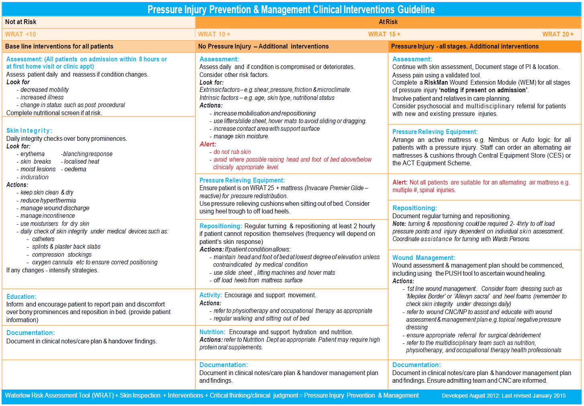

Attachment 2: Waterlow Risk Assessment Tool
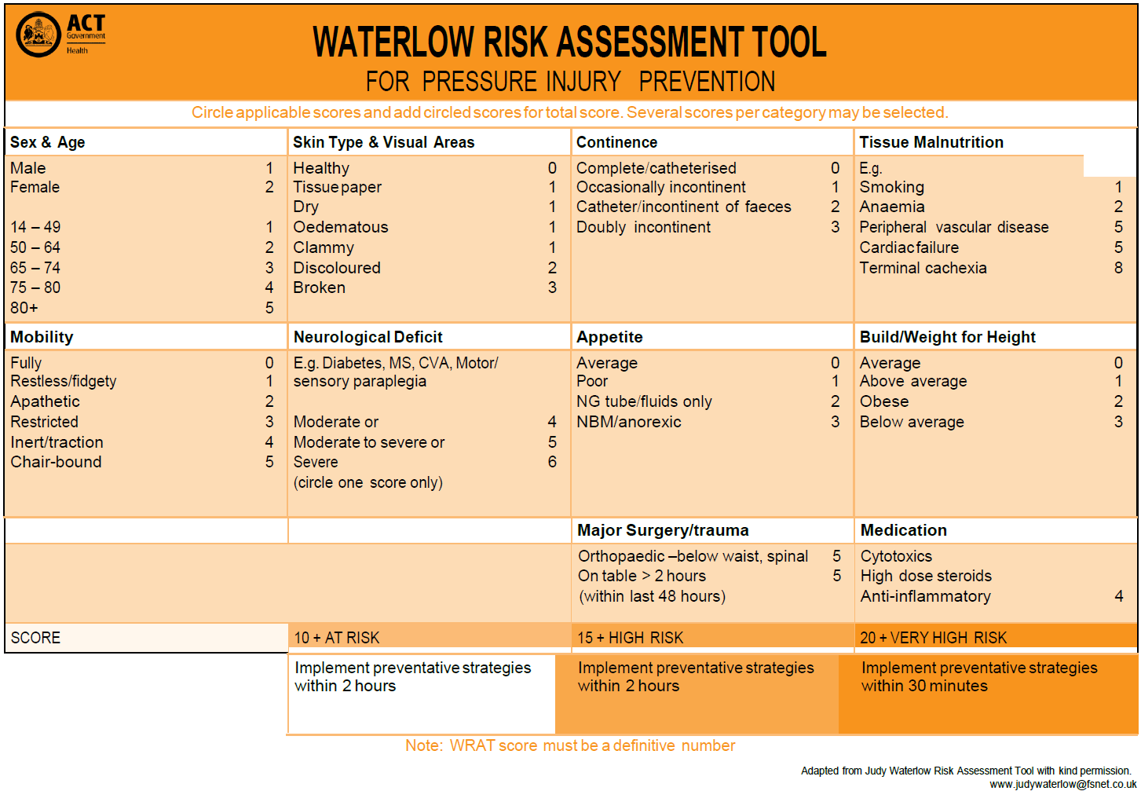

Attachment 3: Braden Q Scale for Paediatric Patients
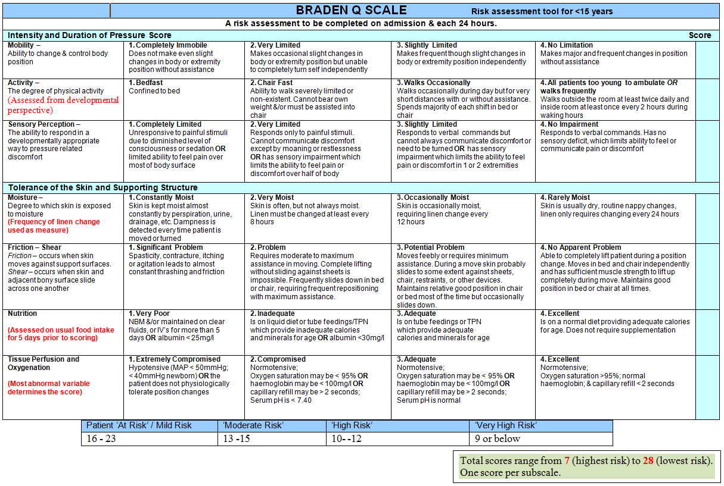
Attachment 4: Neonatal skin risk assessment
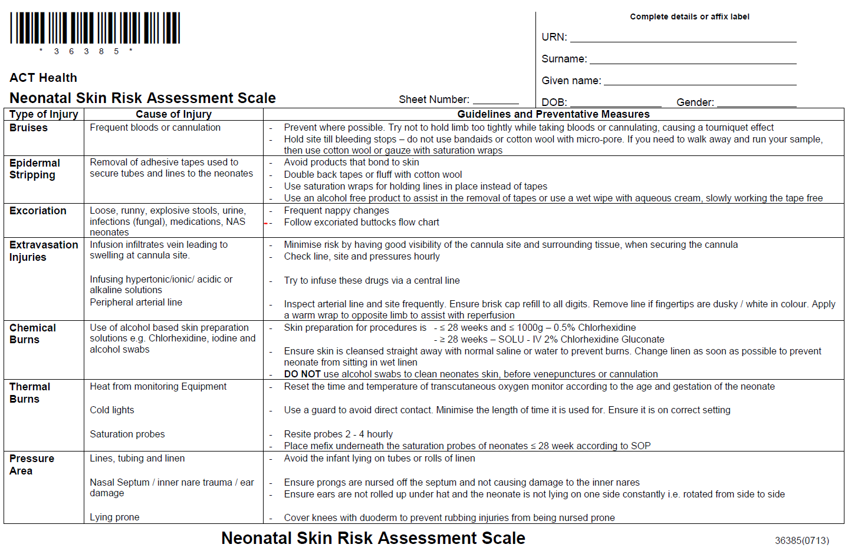
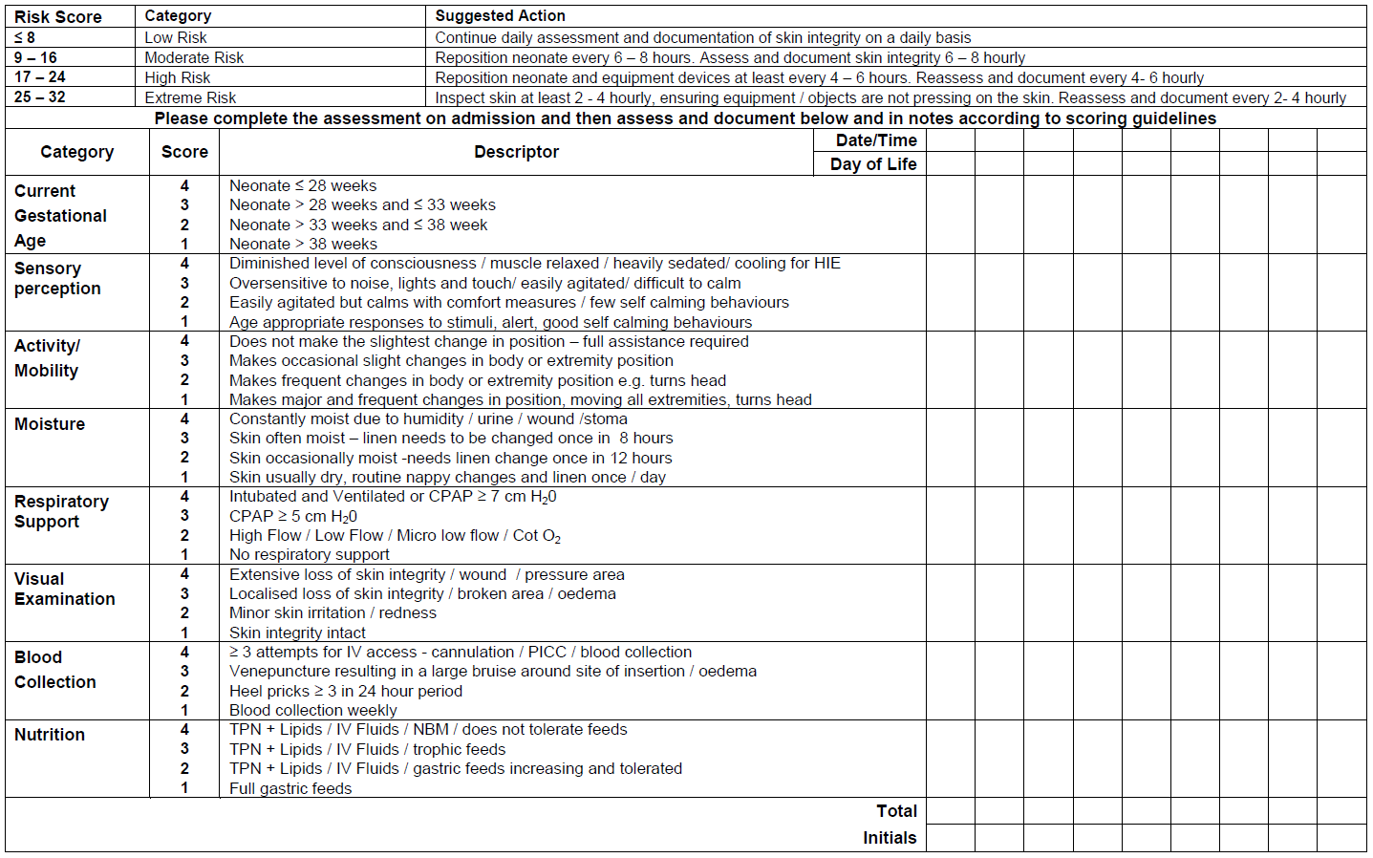

Attachment 5: Modified Waterlow Risk Assessment Tool (used in Maternity and some OPD settings)
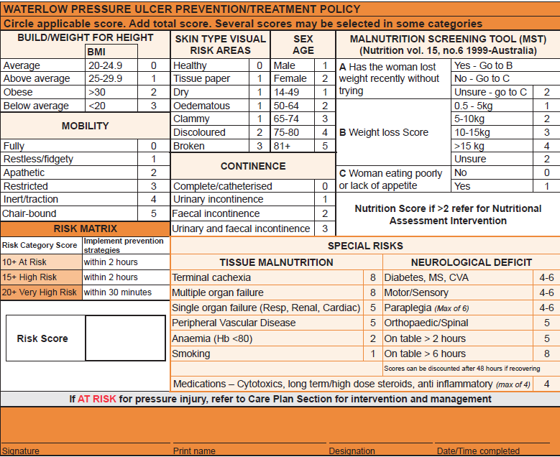

Attachment 6: Braden Risk Assessment Tool (used by Occupational Therapy)
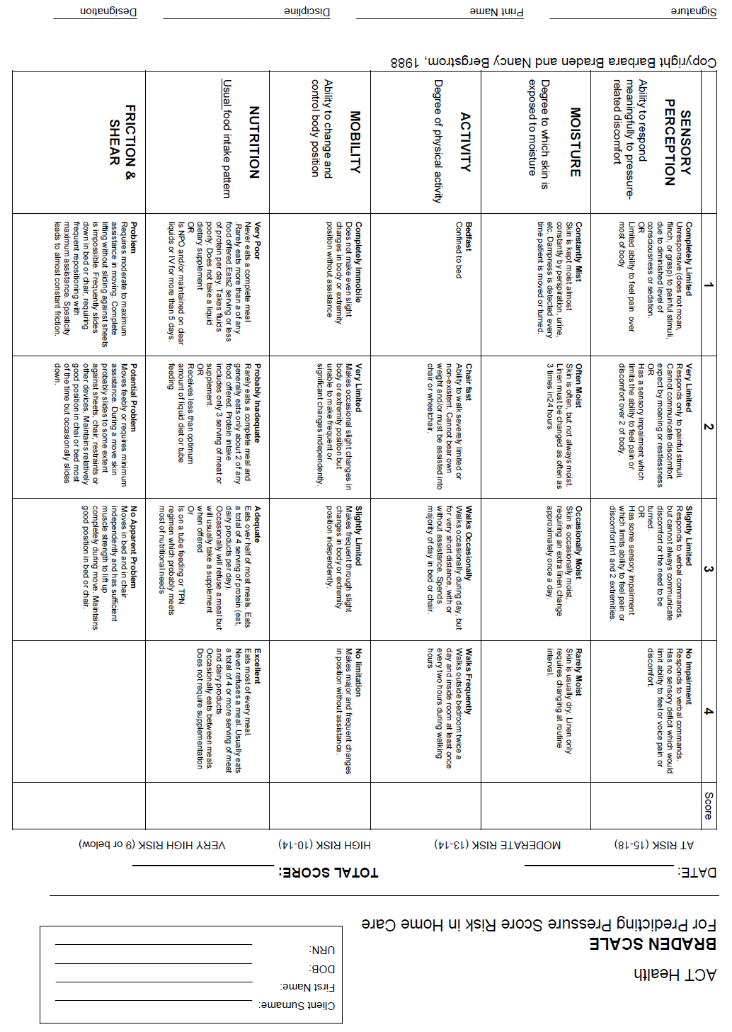

Attachment 7: Classification photos
